Machine-Learning-Based Thermo-Mechanical and
Reliability Analysis of FCBGA Packages with Lid
Bahareh Pourahmad and Moulay Abdallah Cherif Louazani
Electrical Engineering, University of Ottawa, Ottawa, Canada
bpour072@uottawa.ca, mcher102@uottawa.ca

Abstract
Flip-chip ball grid array (FCBGA) packages with lids are widely used in high-performance electronic systems because the lid improves thermal spreading and mechanical rigidity. However, the lid also changes the package stiffness distribution and can influence warpage, ELK stress, and solder-joint reliability. This work develops a finite-element-analysis-generated, machine-learning-assisted co-design workflow for predicting and optimizing thermo-mechanical and reliability responses of an FCBGA package with lid. Two datasets were used: an assembly dataset with 300 design points for ELK stress and warpage prediction, and a solder-joint reliability dataset with 300 design points for ∆W_{BGA} and ∆W_{bump} prediction. Artificial neural network (ANN) and CatBoost gradient-boosting surrogate models were evaluated per target, with the ANN requiring input standardization, target scaling, early stopping, and cross-validated hyperparameter tuning to become competitive. CatBoost delivered the best hold-out accuracy for all five objectives, with test R² values of 0.9851 for ELK stress and 0.9796 for warpage after underfill cure, a moderate 0.4761 for ∆W_{bump}, and weak fidelity for ∆W_{BGA} (0.1998) and warpage after lid attachment (0.1373), with per-target cross-validated diagnostics reported in Section 3.1. The CatBoost surrogates were then used in a multi-objective co-design workflow using NSGA-II to identify Pareto-optimal designs across five minimized objectives, and a Net Flow Method (NFM) ranking step was applied to select a balanced champion design. The champion’s predictions were assessed through a proxy validation against the nearest existing DOE/FEA simulation case rather than any new ANSYS re-simulation. The results show that the workflow can provide useful design guidance for FCBGA-with-lid packages, while also identifying responses that require additional simulation data or higher-fidelity validation.
Keywords: FCBGA with lid, flip-chip package, machine learning, finite element analysis, warpage, ELK stress, solder joint reliability, artificial neural network, CatBoost.

Introduction
Flip-chip ball grid array (FCBGA) packages are a workhorse interconnect platform for high performance computing, artificial-intelligence accelerators, data-center processors, and automotive electronics, because the face-down die attachment provides high input/output density, short interconnect paths, and favorable electrical and thermal behavior. The same drivers that motivate these packages—rising power density, larger die and substrate footprints, and heterogeneous multichip integration—also intensify their thermo-mechanical demands. Large fan-out and multi-chip module architectures for HPC and AI, for example, make warpage control across multi-layered redistribution stacks and solder-joint integrity central process concerns [1], while the growing power envelope elevates heat extraction to a first-order design constraint that detailed thermal-resistance network models of FCBGA assemblies have been developed to quantify [2]. Across all of these architectures, the coefficient-of-thermal-expansion (CTE) mismatch among the silicon die, organic substrate, underfill, solder joints, lid or heat spreader, and printed circuit board is the common root cause of package warpage, interconnect stress, solder-joint fatigue, delamination, and cracking during assembly cool-down and thermal cycling.
To manage heat and mechanical rigidity simultaneously, high-performance FCBGA products increasingly adopt a metallic lid or heat spreader bonded through a thermal interface material (TIM). The lid, however, plays a double-edged role. On one hand it spreads heat and stiffens the assembly; on the other it changes the package stiffness distribution and can shift, rather than simply reduce, the critical stresses. Chen et al. combined finite-element modeling, warpage measurement, and sub-modeling to predict the thermo-mechanical reliability of automotive high-performance FCBGA packages under thermal cycling, underscoring how driver-assistance workloads push these packages into harsher operating envelopes [3]. Focused lid studies make the double-edged effect explicit: Jeronimo et al. showed that the choice of lid material simultaneously governs warpage, solder reliability, and TIM reliability for automotive FCBGA applications, so that no single lid material is optimal for all responses [4]; Peng et al. demonstrated that adding a lid measurably redistributes the stress carried by the underfill in flip-chip packages [5]; and Jung et al. found that lid-adhesive and underfill material choices strongly modulate module-level stress in 2.5D heterogeneous packages, with glass-transition temperature, modulus, and CTE all acting as leverage variables [6]. Collectively these works establish that lid geometry and material selection are genuine design variables coupled to warpage and reliability not passive add-ons—which is precisely the coupling this study seeks to model.
Finite-element analysis (FEA) has become the primary tool for predicting package warpage and process-induced deformation, and a substantial body of work establishes both its capabilities and the physics that make warpage hard to predict. Ramdas et al. showed that substrate-core CTE is a dominant lever for the warpage of large FCBGA packages with stiffener rings, and that which CTE mismatch dominates can itself change with package configuration [7]. A recurring theme is that warpage is process-history dependent rather than a single elastic response: Cheng et al. and Chen et al. used process-dependent simulation to track warpage evolution through fabrication of flip-chip package-on-package assemblies, capturing viscoelastic and cure-shrinkage effects [8][9], while Salahouelhadj et al. validated FCBGA warpage predictions against projection-Moire mea-surements up to 250°C, using nanoindentation to feed accurate temperature-dependent properties into the model [10]. The molding-compound and underfill cure process is a particularly strong warpage driver: Baek et al. quantified the effect of epoxy-molding-compound cure shrinkage on package warpage [11], Um et al. optimized post-cure temperature profiles to reduce warpage by accounting for cure shrinkage and viscoelasticity [12], and Lin established a chemical-shrinkage and cure-dependent viscoelastic FEA framework for warpage of ultra-thin molded-underfill packages [13]. The consistent message of this literature is that accurate warpage prediction depends on process history and material state that are not fully captured by geometry and room-temperature properties alone—a point that directly anticipates the weakly learnable warpage response reported later in this work.
Underfill is the other decisive mechanical element, coupling the die to the substrate and redistributing thermal-mismatch shear away from individual joints. Plachy´ et al. reviewed underfill reliability-improvement methods and catalogued how underfill modulus, CTE, and filler content trade off warpage against interconnect protection [14], motivating the paired treatment of underfill (E,CTE) adopted as design variables here.
On the reliability side, solder-joint thermal fatigue is the principal board-level and first-level failure mode, and energy-based damage metrics are the accepted life indicators. Gao and Kwak predicted solder-joint reliability and thermal-fatigue life for automotive microelectronics using thermal cycling, Moire interferometry, and crack-growth analysis [15]; Apalowo´ et al. characterized the thermal-fatigue life and intermetallic-compound evolution of SAC305 BGA joints under accelerated thermal cycling [16]; and Yang and Xu predicted the thermal-fatigue life of an Ag2.5Sn flip-chip solder joint [17]. These studies motivate the use of per-cycle inelastic-work-density metrics (∆W) as the reliability objectives in the present study, and they highlight that solder-alloy composition is a first-order variable. Related failure physics in the surrounding dielectrics, such as subcritical crack propagation in solder-resist materials under cyclic loading [18], reinforce that both the joints and the brittle die-level dielectrics must be tracked.
Because high-fidelity FEA over many design variables is computationally expensive, machine learning (ML) has emerged as a surrogate-modeling layer that accelerates design-space exploration. Wu and Chu coupled FEA-generated data with ML for structural design optimization of flip-chip packages [19]; Zhang et al. combined FEA and ML to predict and optimize warpage of a flip-chip structure [20]; and Panigrahy et al. used a deep neural network trained on FEA to estimate memory-IC package warpage rapidly [21]. Most closely related to the present work, Rafiee et al. proposed a thermo-mechanical co-design framework for 2.5D silicon/glass-interposer packages that chains FEA-generated data, per-target surrogates, NSGA-II multi-objective optimization, and a Net Flow Method ranking to select a champion design [22]. A common limitation across this ML-for-packaging literature, however, is that surrogate quality is usually reported only for the responses the models predict well; the responses that cannot be learned from the available design variables, and the consequences of optimizing over such weak surrogates, are rarely made explicit.
Against this background, a gap remains for a compact, honestly diagnosed ML-based co-design workflow aimed specifically at lidded FCBGA packages and multiple, weakly coupled reliability related responses—one that quantifies not only where surrogate prediction succeeds but where it fails, and propagates that target-dependent trust into the design recommendation. This work addresses that gap. Two FEA-generated datasets are used: an assembly dataset for extreme-low-k (ELK) dielectric stress and warpage prediction (after underfill cure and after lid attachment), and a solder-joint reliability (SJR) dataset for ∆W_{BGA} and ∆W_{bump} prediction. Artificial neural network (ANN) and CatBoost gradient-boosting surrogate models are trained per target with explicit cross-validated quality diagnostics; feature-importance analysis identifies the dominant design parameters for each response; the surrogates drive an NSGA-II multi-objective optimization across five minimized objectives; and a Net Flow Method ranking selects a balanced champion design, whose predictions are scrutinized against the nearest simulated design and interpreted strictly in proportion to each surrogate’s demonstrated fidelity. The overall workflow is summarized in Fig. 3.

Methods

Package Architecture and FEA Modeling
The package studied here is a lidded FCBGA assembly (Fig. 1): a die attached face-down to an organic build-up substrate through solder-capped Cu-pillar bumps, with a capillary underfill redistributing thermal-mismatch shear away from individual joints. A metallic lid is bonded above the die through a thermal interface material (TIM) with its foot on the substrate periphery, acting as both heat spreader and stiffener that constrains post-attach warpage. The substrate core whose thickness, modulus, and CTE are design variables—dominates bending stiffness and thermal expansion, and a BGA solder-ball array forms the second-level interconnect and primary board-level reliability concern.
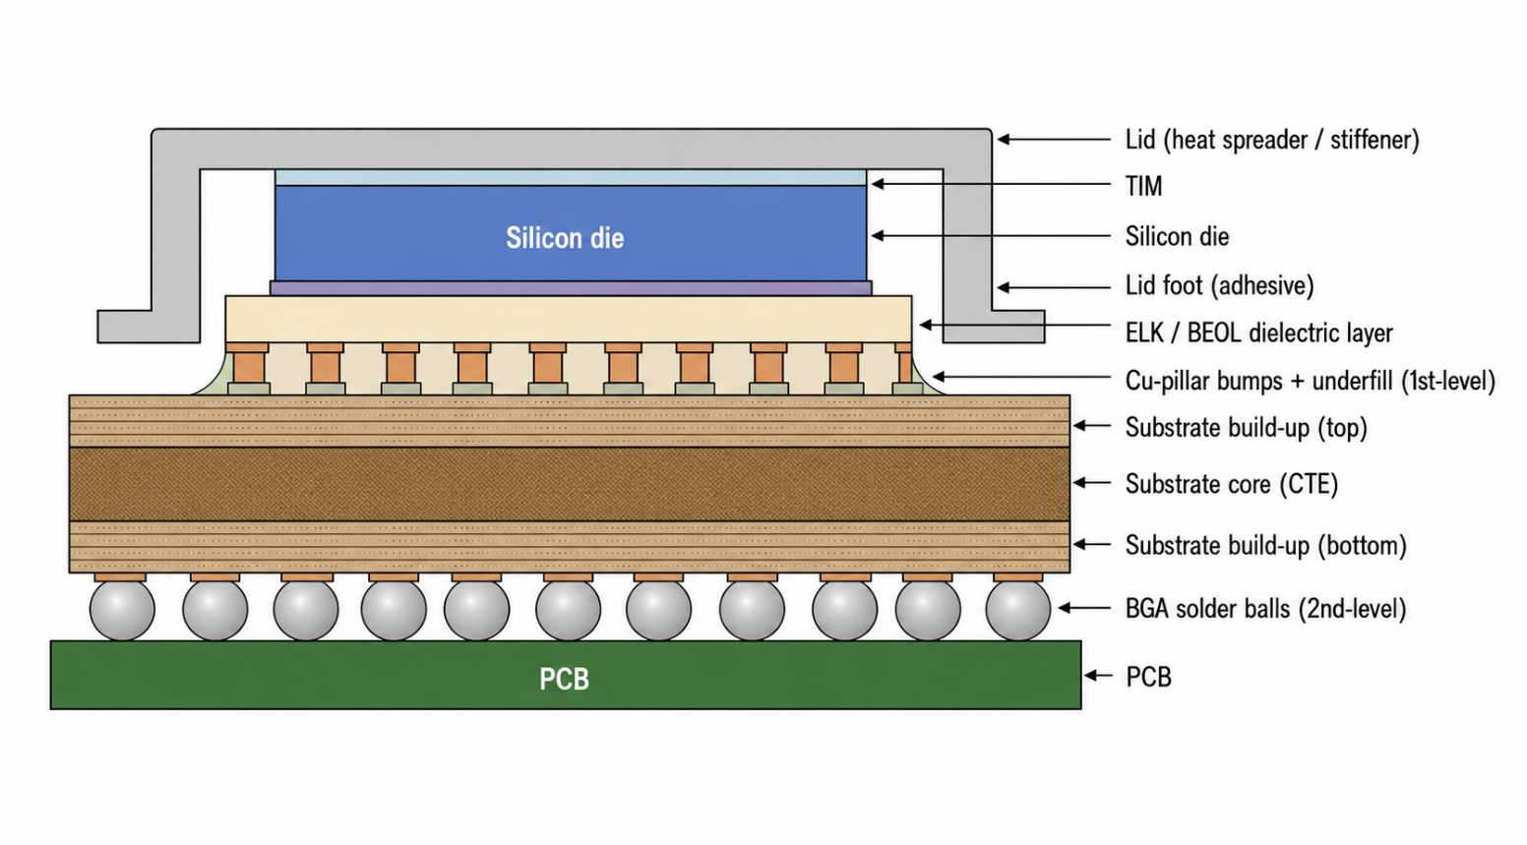Figure 1. Schematic cross-section of the lidded FCBGA package (not to scale), showing the face-down die on the organic substrate through underfilled Cu-pillar bumps, the ELK dielectric beneath the die back-end-of-line, the TIM-bonded lid footed to the substrate periphery, and the second-level BGA array to the PCB.
These features concentrate the design problem at coupled interfaces. During cool-down, the die-to-substrate CTE mismatch drives warpage and stresses the fragile extreme-low-k (ELK) dielectric beneath the bump pads; during thermal cycling, the same mismatch drives cyclic inelastic deformation and fatigue in the first-level (bump) and second-level (BGA) joints. The lid modifies both—its attachment changes the warped shape, and its stiffness alters how cyclic strain partitions among interconnect levels.
Two ANSYS finite-element workflows were used to generate the response data, summarized in Table 1.
Table 1. Summary of datasets used in this study.
Dataset | Samples | Target responses
Assembly | 300 | ELK stress, UF-cure warpage, lid-attach warpage
SJR | 300 | ∆W_{BGA}, ∆Wbump

- Assembly simulation. This workflow tracked stress and deformation through the sequential chip-join, underfill-cure, and lid-attach stages of cool-down, producing three responses: ELK dielectric stress beneath the bump array (the accepted white-bump/ELK-cracking indicator), warpage after underfill cure (governing assembly yield and coplanarity), and warpage after lid attachment (setting final flatness for surface-mount assembly and heat-sink integration).
- Solder-joint reliability (SJR) simulation. This workflow applied JEDEC-style accelerated thermal cycling and extracted two damage indicators from the per-cycle change in accumulated inelastic work density—∆W_{BGA} for the critical BGA joint and ∆W_{bump} for the critical Cu-pillar bump joint—which are standard energy-based fatigue indicators in Darveaux-style solder life models.

FEA Model, Mesh, and Boundary Conditions
The finite-element models were built in ANSYS using a three-dimensional (3-D) slice representation of the package stack-up, in which a 1-mm-thick out-of-plane slice is modeled with solid elements under symmetry/coupling boundary conditions on the cut faces.
(a) Slice model (b) Meshed model
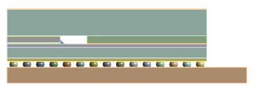
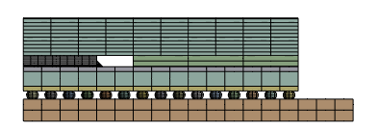

Figure 2. ANSYS 3-D slice model and corresponding mesh of the lidded FCBGA package. The slice captures the through-thickness layer sequence and critical interconnect regions at reduced cost relative to a full-package model, and the same mesh strategy is used for all 300 DOE cases.
The layers were meshed with 3-D solid elements, locally refined near the bump/ELK region and the outermost BGA joints where stress and damage localize; the same strategy was held across all DOE cases so response differences arose from design rather than mesh changes. The SJR metric was extracted as a volume-averaged inelastic work density to reduce mesh-singularity sensitivity. Constant properties are summarized in Table 2.
Table 2. Constant geometric and material properties held fixed across the simulations.
Category | Parameter | Value | Units
Geometry | Die length / width | 5 | mm
 | ELK layer thickness | 1 | µm
 | Substrate build-up thickness | 0.26 | mm
 | Substrate length | 15 | mm
 | BGA pitch | 1 | mm
 | PCB length | 18 | mm
Material | Silicon die (E, CTE) | 131, 2.8 | GPa, ppm/K
 | ELK dielectric (E, CTE) | 10, 6.5 | GPa, ppm/K
 | USG dielectric (E, CTE) | 66, 0.57 | GPa, ppm/K
 | Cu pillar (E, CTE) | 110, 17 | GPa, ppm/K
 | Lid / stiffener, stainless steel (E, CTE) | 193, 17 | GPa, ppm/K
 | Underfill 1 (E, CTE) | approx. 10.5–11, 28–31 | GPa, ppm/K
 | Underfill 2 (E, CTE) | approx. 6.7–6.8, 28–35 | GPa, ppm/K

Material levels were assigned rather than fixed constants: the orthotropic substrate core, the lid adhesive, and the underfill were each sampled at three paired (E, CTE) levels matching Table 3 (core in-plane CTE 3, 6, 9 ppm/K). The underfill and PCB used temperature-dependent tabular properties, the PCB CTE spanning approximately 17.37–25.79 ppm/K. The Cu-pillar bump and BGA solders used the rate-dependent Anand viscoplastic model so that alloy selection affected the mechanical response; the Anand parameters were taken from the ANSYS material database, and the per-cycle inelastic work density ∆W was the reliability metric.
A design-of-experiments campaign of 300 design points spanned both workflows, each point carrying a common Design ID so assembly and reliability responses could be paired row-by-row. The points came from a discrete, multi-level grid rather than a continuous Latin Hypercube plan: several variables are categorical or restricted to qualified levels, and grid-restricted candidates keep the optimizer inside the exactly simulated design space, so every optimized design stays directly simulatable in ANSYS. Each variable took one of the predefined levels in Table 3, with four SAC-family alloys per solder variable.
Table 3. Design variables and discrete DOE levels used in the assembly and SJR datasets.
Design variable | Levels | Units
Bulk silicon thickness | 0.25, 0.50, 0.75 | mm
Bump solder height | 0.02, 0.04, 0.06 | mm
Substrate core thickness | 0.40, 0.80, 1.20 | mm
Substrate core CTE (paired w/ E) | 3, 6, 9 | ppm/K
Underfill CTE (paired w/ E) | 20, 25, 30 | ppm/K
Lid foot width | 3, 6, 9 | mm
Lid thickness | 1.0, 1.5, 2.0 | mm
Cu-pillar bump solder material | SAC105/205/305/405 | —
BGA solder material | SAC105/205/305/405 | —
Cu-pillar pitch–diameter (const.) | 0.125 | —

Substrate-core and underfill (E, CTE) properties were paired because they are not independently selectable in practice—a given laminate or underfill has a specific modulus–CTE combination—so pairing prevents the optimizer from exploring physically unrealistic material combinations. The Cu-pillar pitch–diameter variable was constant in both datasets and removed before surrogate training.

Data Preparation and Feature Engineering
The raw exports were cleaned into two harmonized datasets—one for assembly responses, one for reliability. Shared design variables were given identical labels, constant or non-informative columns were removed, and the tables were merged on Design ID into a master table of all 300 designs (all variables and five responses per row) that also serves the objective-correlation analysis (Section 3.3) and the nearest-neighbor validation proxy (Section 2.7).
For model training, the categorical variables (the two solder materials and the paired material-level variables) were one-hot encoded. CatBoost received the numerical variables unscaled—tree splits are invariant to monotone transforms, keeping the pipeline interpretable—whereas the ANN inputs were standardized and its targets scaled through a TransformedTargetRegressor, since gradient-trained perceptrons are highly scale-sensitive; omitting this causes the catastrophic ANN failures in Section 3.1.
Two safeguards against target leakage were enforced: responses were never used as input features, and assembly and SJR targets used their own dataset-specific feature sets. Each target was modeled independently—its own split, pipeline, and fitted model—preferred over multi-output regression because the targets differ in scale, noise, and learnability, and because this permits per-target model selection.
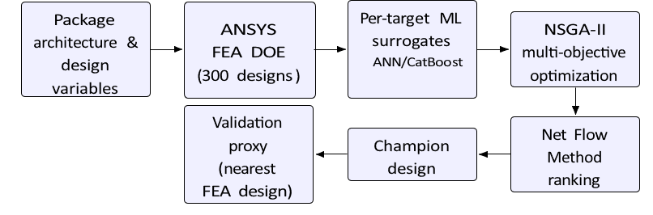
Figure 3. End-to-end FEA–ML–NSGA-II–NFM co-design workflow: FEA over a 300-point DOE builds the datasets; per-target ANN and CatBoost surrogates replace the solver during NSGA-II optimization; the Net Flow Method ranks the Pareto front to a champion; and a nearest-neighbor FEA proxy checks the champion’s predictions.

Machine-Learning Surrogate Modeling
Surrogate models replaced the expensive ANSYS simulations during optimization, where NSGA-II requires on the order of 10⁴ objective evaluations—far beyond direct FEA. Two families were compared per target: a multilayer-perceptron artificial neural network (ANN), learning a smooth nonlinear mapping from the design vector, and a CatBoost gradient-boosting regressor, which fits shallow trees sequentially to the ensemble residuals and natively handles mixed continuous/categorical data—spanning the dominant paradigms for tabular data and testing which suits a small 300-point DOE.
For every target, the data were split 80/20 (random state = 42), and five-fold cross-validation produced validation sweeps over hyperparameters and learning curves over training-set size. CatBoost depth was swept over {2, 3, 4, 5, 6}; the ANN grid covered hidden-layer architectures ((16), (32), (32, 16), (64, 32)), L2 strength α ∈ {10⁻⁴, 10⁻³, 10⁻²}, and learning rate ∈ {10⁻⁴, 10⁻³}—24 configurations per target. These identified the capacity beyond which complexity only overfit, whether 300 points sufficed, and responses unlearnable by any configuration (Section 3.1).
The final CatBoost surrogates used a fixed depth of 4 with 100 boosting iterations for every target; the final ANN used the best per-target configuration—(64, 32) hidden units for four targets, (32, 16) for post-lid-attach warpage—with early stopping and up to 3000 iterations. A single fixed depth keeps the surrogates simple, comparable, and less prone to selection bias on 300 points. To isolate preprocessing effects, a baseline ANN (unscaled inputs/targets, default settings) and an improved ANN (standardization, target scaling, early stopping, tuning) were compared in Section 3.1.
Each model was an sklearn Pipeline whose ColumnTransformer one-hot encoded the categoricals and passed the numericals through unchanged (CatBoost) or standardized (ANN, with a TransformedTargetRegressor scaling targets and inverse-transforming predictions), guaranteeing identical feature construction at training and at optimization. Quality was assessed by R² and MSE on training and hold-out sets, with validation and learning curves, parity plots, and feature-importance analysis; the better family was selected per target, and CatBoost was selected for all five objectives (Section 3.1).

Multi-Objective Optimization Using NSGA-II
Surrogate-assisted optimization used NSGA-II (pymoo), the standard elitist multi-objective evolutionary algorithm for moderate objective dimension, which maintains a candidate population, ranks by non-domination level, and preserves front diversity via crowding distance, approximating the whole Pareto front in one run. The settings (Table 4)—population 150, 100 generations, seed 42—give 15,000 surrogate evaluations per objective.
Table 4. NSGA-II optimization settings used for multi-objective co-design.
Parameter | Value
Optimization algorithm | NSGA-II
Population size | 150
Number of generations | 100
Random seed | 42
Number of design variables | 9
Number of objectives | 5
Objective direction | Minimize all objectives
Design space | Discrete DOE levels

Decision variables were restricted to the discrete DOE levels, keeping every candidate inside the sampled space—so the non-extrapolating surrogates stayed within their region of validity—and making every Pareto solution a directly simulatable grid configuration. Categorical variables were integer-coded and decoded before preprocessing.
Five objectives were minimized simultaneously—ELK stress, warpage after underfill cure, warpage after lid attachment, ∆W_{BGA}, and ∆W_{bump}—with no scalarization or weighting at this stage; trade-off resolution was deferred to Section 2.6. The 150 exported Pareto-optimal solutions carry ML-surrogate objective values only—none was re-simulated in ANSYS here—so their fidelity inherits the per-objective surrogate quality of Section 3.1.

Net Flow Method Ranking
The 150-point Pareto front maps achievable trade-offs but gives no single recommendation, so it was ranked with the Net Flow Method (NFM), a PROMETHEE-family outranking approach. For every ordered pair and objective, NFM derives a preference contribution from the objective difference, aggregates these into pairwise concordances subject to a veto, and assigns each solution a net flow score—its outranking strength over the set minus the strength by which it is outranked.
Equal weights were assigned to all five objectives, reflecting no a-priori preference among stress, warpage, and reliability. Three thresholds, each relative to the objective’s Pareto-set range, controlled the comparisons: indifference Q = 5% (differences below which are noise), preference P = 15% (above which a difference expresses full preference, interpolating linearly between Q and P), and veto V = 30% (beyond which a severe single-objective disadvantage blocks outranking). The veto—distinguishing outranking from a weighted sum—prevents a design that is catastrophically poor on one objective from being rescued by the others. Solutions were sorted by descending net flow score, and NetFlow rank 1 was the champion.

Validation Approach
A full ANSYS re-simulation of the champion was not completed, so its responses were assessed with a nearest-neighbor validation proxy: the champion design vector was compared against all 300 simulated designs using a mixed metric—squared Euclidean distance over the numerical variables plus a unit penalty per differing categorical level—and the nearest neighbor, FEA Design ID 277, was retrieved for comparison against the champion’s ML predictions. Because each discrepancy confounds the surrogate’s genuine error with the true physical difference between the champion and this nearby design, the proxy is a plausibility check conditioned on per-target surrogate quality, not a re-simulation of the champion; sign-off-grade validation would require a dedicated ANSYS re-solve.

Results

Surrogate Model Performance
The ANN proved highly sensitive to preprocessing. Table 5 compares the hold-out test R² of the baseline ANN—trained on unscaled inputs and targets with default hyperparameters—with the improved ANN of Section 2.4, and Fig. 4 visualizes the comparison. The baseline ANN failed catastrophically on the small-magnitude targets, with strongly negative test R² for warpage after underfill cure (−10.74), warpage after lid attachment (−2.72), and ∆W_{BGA} (−1.64), meaning that it predicted held-out data far worse than the constant mean predictor. Input standardization, target scaling through a TransformedTargetRegressor, early stopping, and cross-validated tuning of the hidden-layer sizes, L2 regularization, and learning rate recovered the ANN to a test R² of 0.949 for warpage after underfill cure and improved every other target, most notably ∆W_{bump} (0.172 to 0.468) and ELK stress (0.872 to 0.899). Target scaling was the single most consequential improvement: without it, the mean-squared-error loss on raw warpage values of order 10⁻² mm provides gradients too poorly conditioned for stable training.
Table 5: Baseline versus improved ANN hold-out performance (test R²) for each target response.
Objective | ANN Baseline Test R² | Improved ANN Test R²
ELK stress | 0.872 | 0.899
Warpage after UF cure | −10.74 | 0.949
Warpage after lid attach | −2.72 | 0.095
∆W_{BGA} | −1.64 | 0.198
∆W_{bump} | 0.172 | 0.468

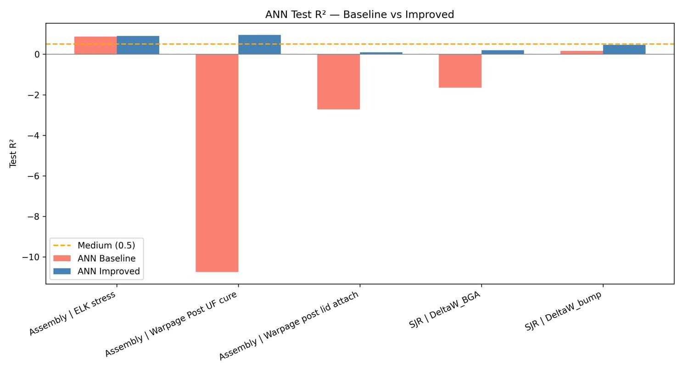
Figure 4: Test R² of the baseline and improved ANN for each target response. Input standardization, target scaling, early stopping, and cross-validated hyperparameter tuning recover the ANN from catastrophic failure on the warpage-related targets.
Table 6 compares the improved ANN with CatBoost on the hold-out test set. CatBoost matched or outperformed the improved ANN on every objective: decisively for ELK stress (0.985 versus 0.899) and warpage after underfill cure (0.980 versus 0.949), and marginally for the remaining targets, where both families are weak (warpage after lid attachment, ∆W_{BGA}) or of medium quality (∆W_{bump}, 0.476 versus 0.468). CatBoost was therefore selected as the surrogate for all five objectives in the optimization stage.
Table 6: Final hold-out comparison (test R²) of the improved ANN and CatBoost surrogates.
Objective | ANN Test R² | CatBoost Test R² | Interpretation
ELK stress | 0.899 | 0.985 | CatBoost performs best
Warpage after UF cure | 0.949 | 0.980 | CatBoost performs best
Warpage after lid attach | 0.095 | 0.137 | Both models are weak
∆W_{BGA} | 0.198 | 0.200 | Both models are weak
∆W_{bump} | 0.468 | 0.476 | CatBoost slightly better; medium quality

Table 7 summarizes the hold-out performance of the selected CatBoost surrogate for each target, and Fig. 5 compares the test R² values across all five targets against the quality thresholds used in this work (R² ≥ 0.90 “very good”, 0.50–0.90 “medium”, below 0.50 “weak”). The CatBoost surrogates reported in Table 7 are the models actually used inside NSGA-II, and their hold-out metrics are the headline figures quoted in the abstract and conclusion. The results divide sharply into tiers. Two targets were predicted with very high accuracy: ELK stress (test R² = 0.9851, test MSE = 0.0723) and warpage after underfill cure (test R² = 0.9796, test MSE = 6.06×10⁻⁶). ∆W_{bump} reached a borderline-medium test R² of 0.4761, just below the 0.50 medium threshold. In contrast, warpage after lid attachment (test R² = 0.1373) and ∆W_{BGA} (test R² = 0.1998) were weak surrogate targets.
Table 7: Hold-out performance of the selected CatBoost surrogates for each target response (depth 4, 100 iterations, 80/20 split, seed 42).
Target | Best Model | Train R² | Test R² | Quality
ELK stress | CatBoost | 0.9984 | 0.9851 | Very good
Warpage after UF cure | CatBoost | 0.9971 | 0.9796 | Very good
Warpage after lid attach | CatBoost | 0.8291 | 0.1373 | Weak
∆WBGA | CatBoost | 0.9390 | 0.1998 | Weak
∆Wbump | CatBoost | 0.9453 | 0.4761 | Weak
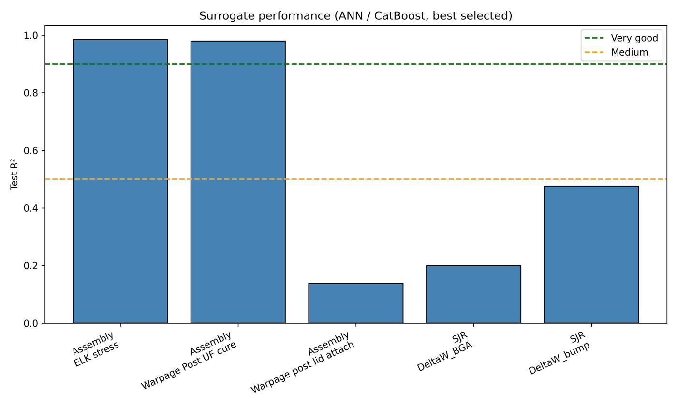
Figure 5: Test R² of the selected CatBoost surrogate for each target response, with quality thresholds indicated.
For the weakly predicted targets, the gap between training and test performance is large—0.8291 versus 0.1373 for post-lid-attach warpage and 0.9390 versus 0.1998 for ∆W_{BGA}. A model that fits 83–94% of the training variance while explaining only 14–20% of unseen variance has memorized configuration-specific patterns rather than learning transferable structure: a classic overfitting signature given the limited 300-point DOE.
The five-fold cross-validation sweeps corroborate and sharpen this diagnosis. For ELK stress, CatBoost achieved a mean CV test R² of 0.9794 at depth 3 and 0.9795 at depth 4, degrading gradually with additional depth (0.9603 at depth 6), while the tuned ANN reached a CV R² of 0.9194, confirming that shallow boosted trees suffice for this smooth response. For warpage after underfill cure, CatBoost peaked at a CV test R² of 0.9808 at depth 3, with the tuned ANN reaching 0.9471. For warpage after lid attachment, however, no tested configuration of either model family achieved a meaningful positive CV test R²: CatBoost was negative at every depth (−0.003 at depth 6 down to −0.106 at depth 5), and the best of the 24 cross-validated ANN configurations reached only 0.026. A negative cross-validated R² means the model predicted held-out data worse than the constant mean predictor—strong evidence that the available design variables simply do not encode this response, rather than that the hyperparameters were poorly chosen. ∆W_{BGA} showed the same qualitative pattern in attenuated form (best CatBoost CV test R² of only 0.114 at depth 6, the latter with a 0.99 training score revealing severe overfitting, and a best ANN CV R² of 0.094), whereas ∆W_{bump} reached a genuinely positive CatBoost CV test R² of 0.588 at depth 2 (0.565 for the tuned ANN), consistent with its borderline-medium hold-out quality. The single-split test R² of 0.1373 for post-lid-attach warpage in Table 7 should therefore be read as an optimistic draw from a distribution whose cross-validated center is near or below zero.
The cross-validation sweeps constitute an important negative result in their own right: no tested CatBoost depth, and none of the 24 cross-validated ANN configurations, materially improved the weak targets, indicating that their weakness is not a hyperparameter artifact but reflects a genuine limitation of the available features and dataset size for these responses. Expanding the model search space cannot substitute for information that is absent from the inputs.
Figure 6 presents the parity plots of FEA-computed versus ML-predicted values for all five targets and both model families (ANN and CatBoost), on training and test sets. The ELK stress and underfill-cure warpage predictions cluster tightly along the identity line in all panels. The post-lid-attach warpage
Table 8: Dominant parameters identified from feature-importance analysis.
Target | Dominant parameters
ELK stress | Solder material, bump solder height
Warpage after UF cure | Substrate core thickness, core properties
Warpage after lid attach | Lid foot width, bump solder height, bulk silicon thickness
∆WBGA | Substrate core properties, BGA solder material, lid foot width
∆Wbump | Bump solder height, underfill properties, substrate core
and ∆W_{BGA}
test predictions, by contrast, scatter widely and exhibit visible regression toward the mean—the model hedges toward the average response because it cannot resolve individual designs, which is exactly the behavior expected from the near-zero CV scores. Figure 7 shows the corresponding learning curves. For the strong targets, the cross-validation score rises with training-set size and converges toward the training score, indicating that 300 points approach sufficiency for these responses. For the weak targets, a persistent gap between the training and validation curves remains at the full dataset size, and the validation curve shows no sign of imminent convergence, indicating that both additional DOE samples and, more fundamentally, additional explanatory features would be required before these responses could be modeled reliably.

Feature-Importance Analysis
Feature-importance analysis was performed to identify the design parameters that most strongly influenced each predicted response. Table 8 summarizes the dominant design parameters for each target response.
For ELK stress, the most important features were the Cu-pillar bump solder material with the SAC105 category carrying particularly high importance followed by bump solder height and bulk. The closer the points are to the diagonal line, the better the agreement between FEA outputs and machine-learning predictions.silicon thickness. The physical interpretation is direct. The solder alloy governs the compliance of the bump interconnect: SAC105, with its low silver content, is the softest of the SAC alloys considered, deforms plastically at lower stress, and thereby changes how thermal-mismatch load is transferred through the Cu pillar into the fragile ELK dielectric stack beneath the bump pad; higher-silver alloys such as SAC405 are stiffer and stronger and transmit load differently. That the one-hot indicator for a single alloy dominates the importance ranking indicates a step-like alloy effect on ELK stress rather than a smooth trend. Bump solder height sets the standoff over which shear deformation is accommodated: a taller, more compliant joint relieves the ELK layers, while a shorter joint stiffens the load path into the die. Bulk silicon thickness controls the bending stiffness of the die and hence the local curvature imposed on the ELK layers during cool-down.
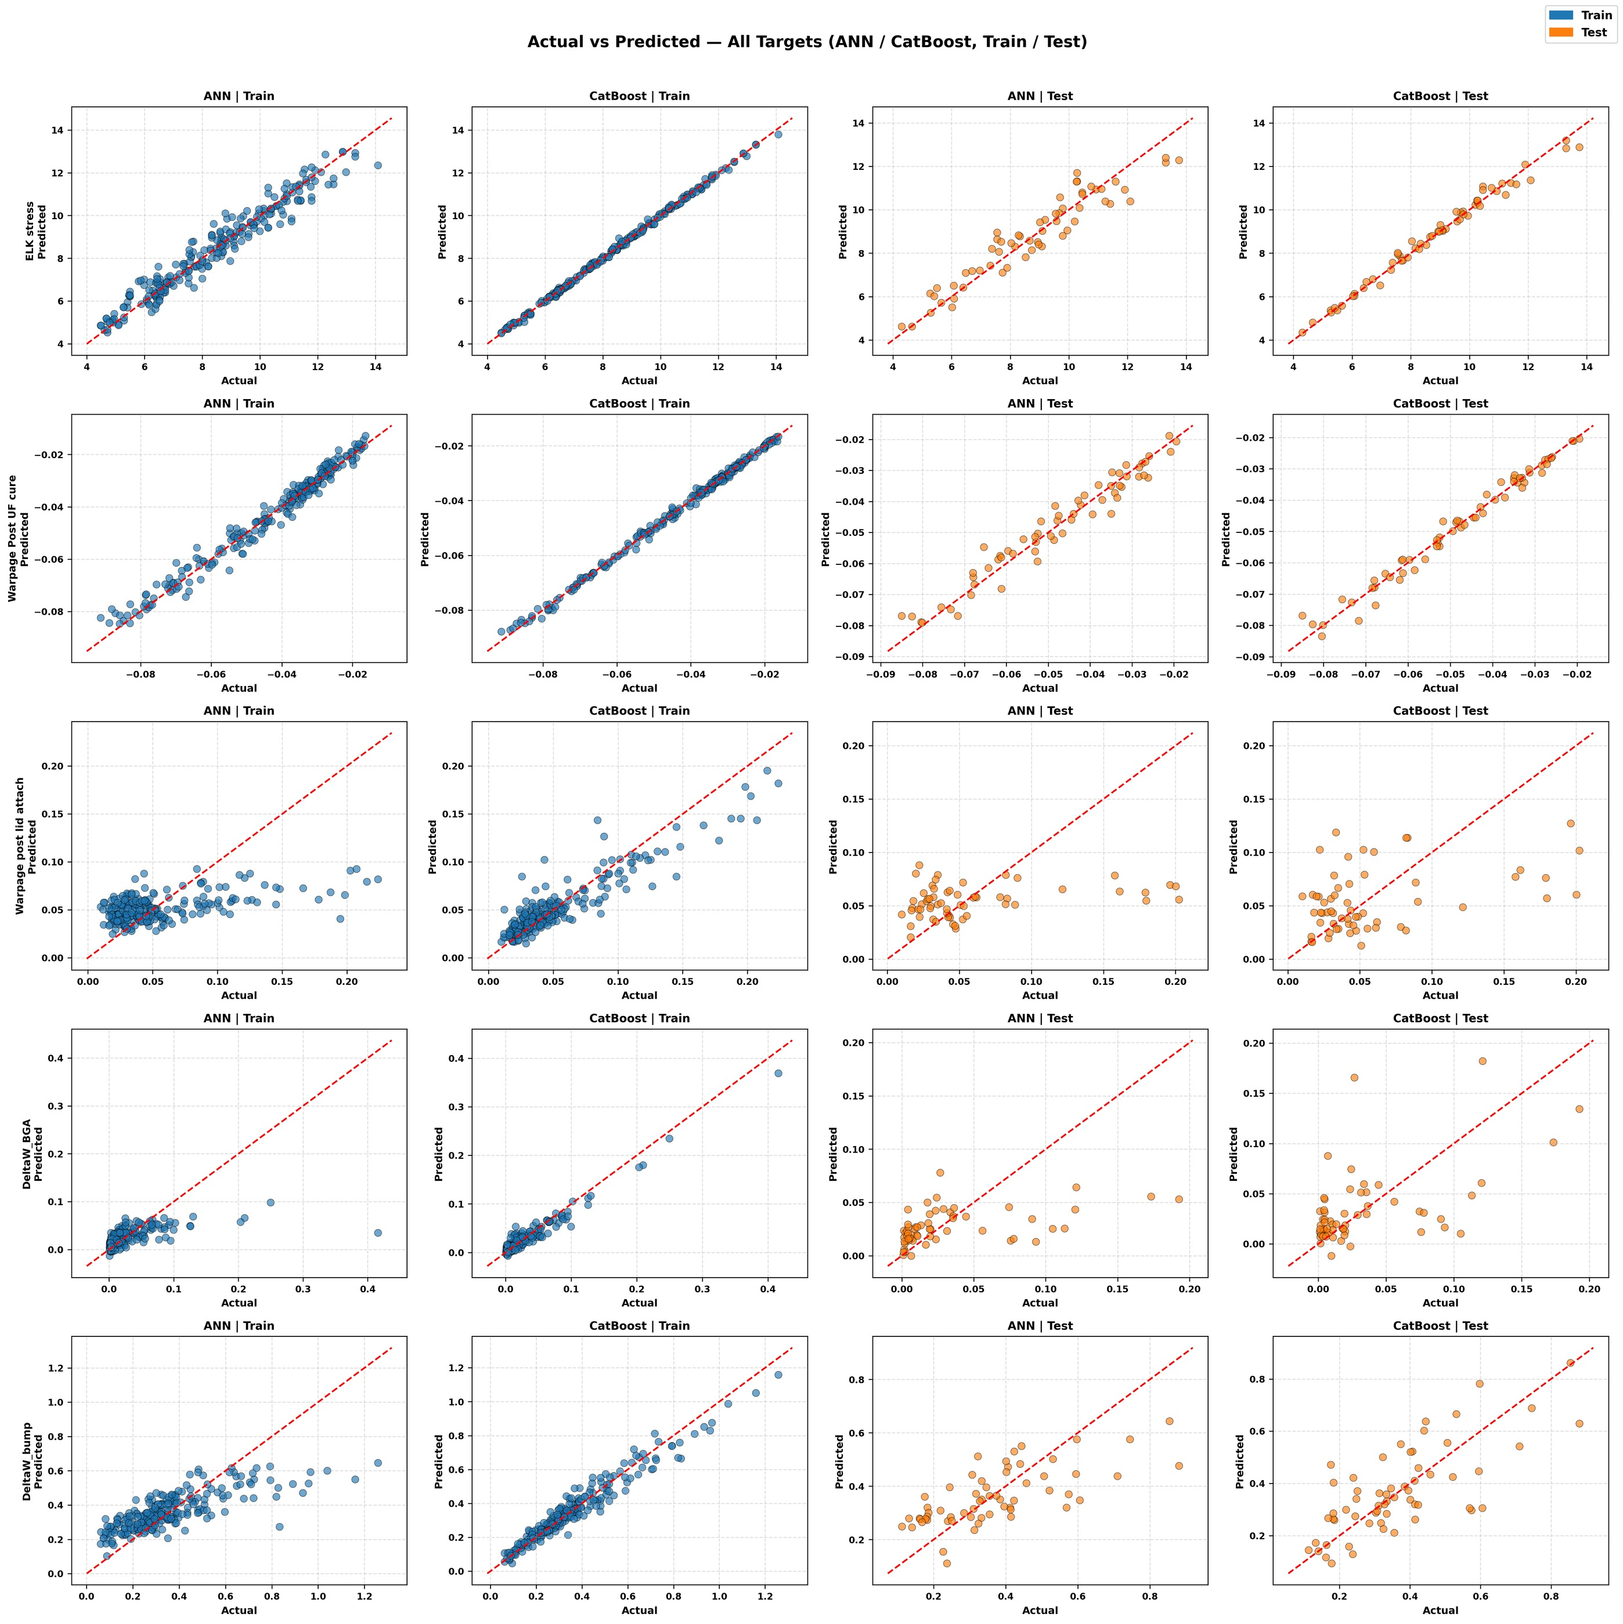
Figure 6: Actual-versus-predicted comparison for all five target responses and both model families (ANN and CatBoost), on training and test sets.
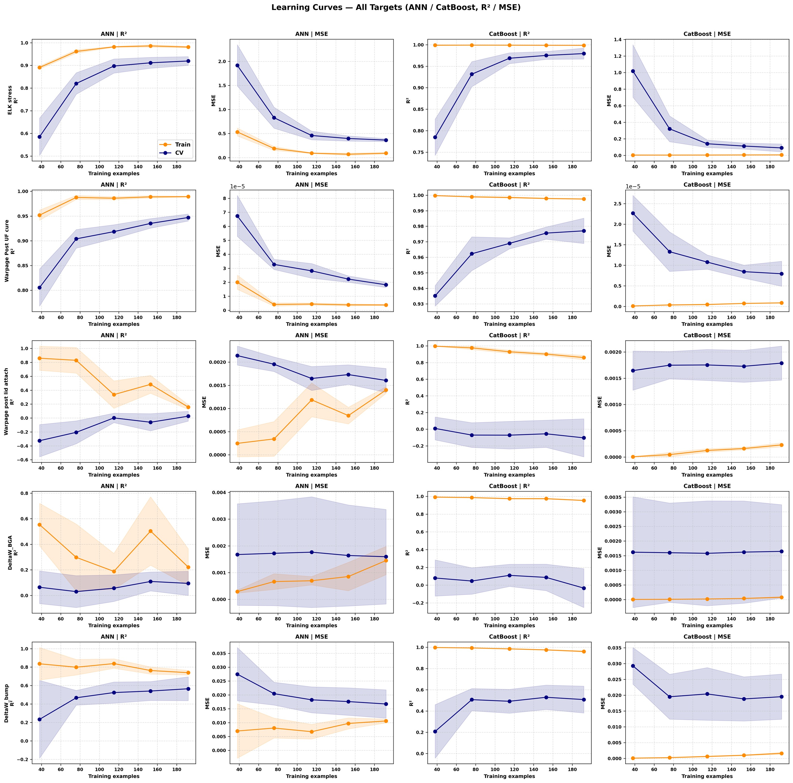
Figure 7: Learning curves for all five target responses and both model families. Persistent train– validation gaps at full dataset size indicate insufficient data or missing features for the weak targets.
For warpage after underfill cure, substrate core thickness was the dominant parameter. This result is physically reasonable because substrate thickness strongly affects the global bending stiffness of the package. Substrate core material properties and bulk silicon thickness were also important, indicating that stiffness and CTE mismatch between the die, substrate, and underfill govern the package warpage during the underfill cure stage, consistent with the process- and materialdependent warpage mechanisms reported in the literature [8, 11, 13].
For ∆W_{BGA}, the leading features were the paired substrate-core elastic modulus and CTE, the BGA solder material—with the soft SAC105 category carrying high importance—the lid foot width, and the paired underfill properties. These drivers are consistent with the accepted mechanics of board-level solder fatigue [15, 16]. The substrate-core properties and the underfill modulus and CTE control the effective stiffness and thermal expansion of the die–underfill–substrate composite, and therefore the global CTE mismatch that the BGA array must absorb against the board each cycle. The BGA solder alloy governs the compliance and inelastic behavior of the second-level joints themselves: the soft, low-silver SAC105 alloy accumulates inelastic work at lower stress than the higher-silver alloys. The role of the lid foot width reflects the lid’s stiffening of the substrate periphery, which modifies how cyclic curvature redistributes strain toward the outermost BGA joints.
For warpage after lid attachment, lid foot width, bump solder height, and bulk silicon thickness were among the most important features, which is reasonable because the lid modifies the stiffness distribution of the package after attachment [4, 5]. For ∆W_{bump}, bump solder height was by far the dominant parameter, followed by the paired underfill properties, the substrate core thickness, and the substrate core properties; this is physically sensible because the bump standoff and the underfill encapsulating the joints together set the local shear strain accommodated by the first-level solder. However, because the prediction accuracy for warpage after lid attachment and ∆W_{BGA} was weak, their importance rankings should be interpreted with caution: importances computed from a model with near-zero generalization describe the model’s overfit structure rather than the underlying physics.
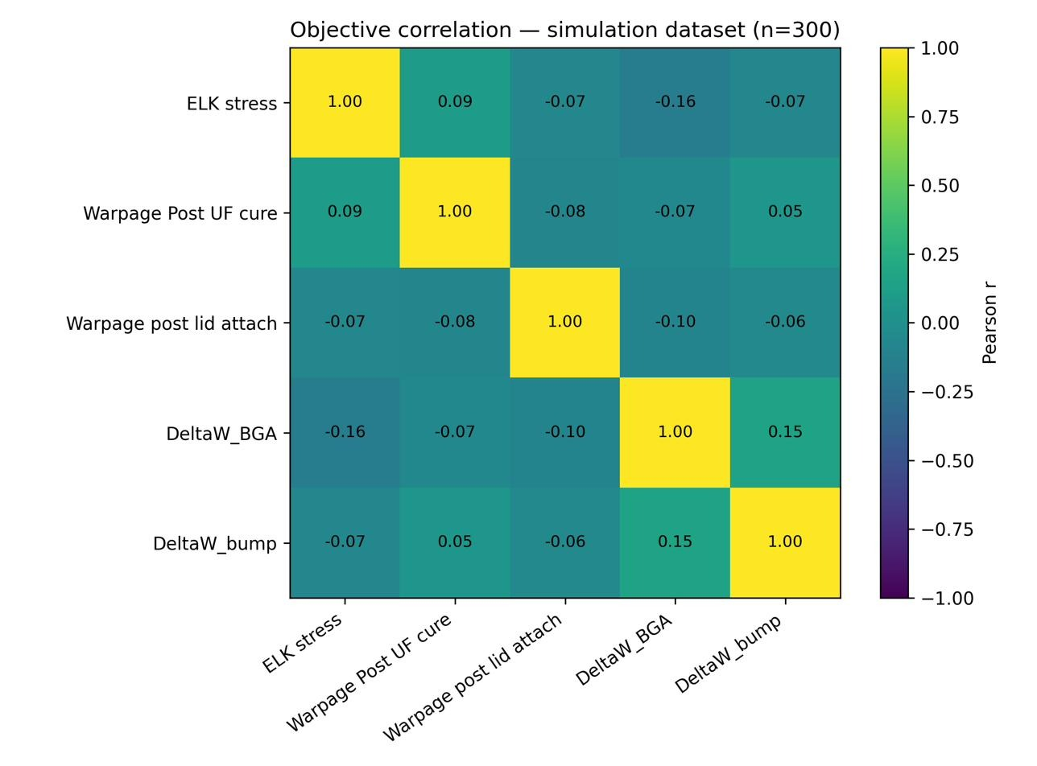
Figure 8: Correlation heatmap of the simulation-based objective responses over the 300 paired design points.

Objective Correlation Analysis
The Pearson correlation structure among the five objectives was evaluated on the 300 paired simulation rows of the master table and is shown as a heatmap in Fig. 8; the corresponding correlation structure recomputed over the 150 Pareto solutions is shown in Fig. 9.
Across the simulation data, all pairwise absolute correlations were below 0.17. The strongest relationships were a weak positive correlation between ∆W_{BGA} and ∆W_{bump} (r = +0.15) and a weak negative correlation between ELK stress and ∆W_{BGA} (r = −0.16). All remaining pairs had |r| below 0.10: for example, ELK stress versus underfill-cure warpage at r = +0.09, post-lid-attach warpage versus ∆W_{BGA} at r = −0.10, and underfill-cure warpage versus ∆W_{bump} at r = +0.05.
Even the two warpage measures—physically successive states of the same package—were
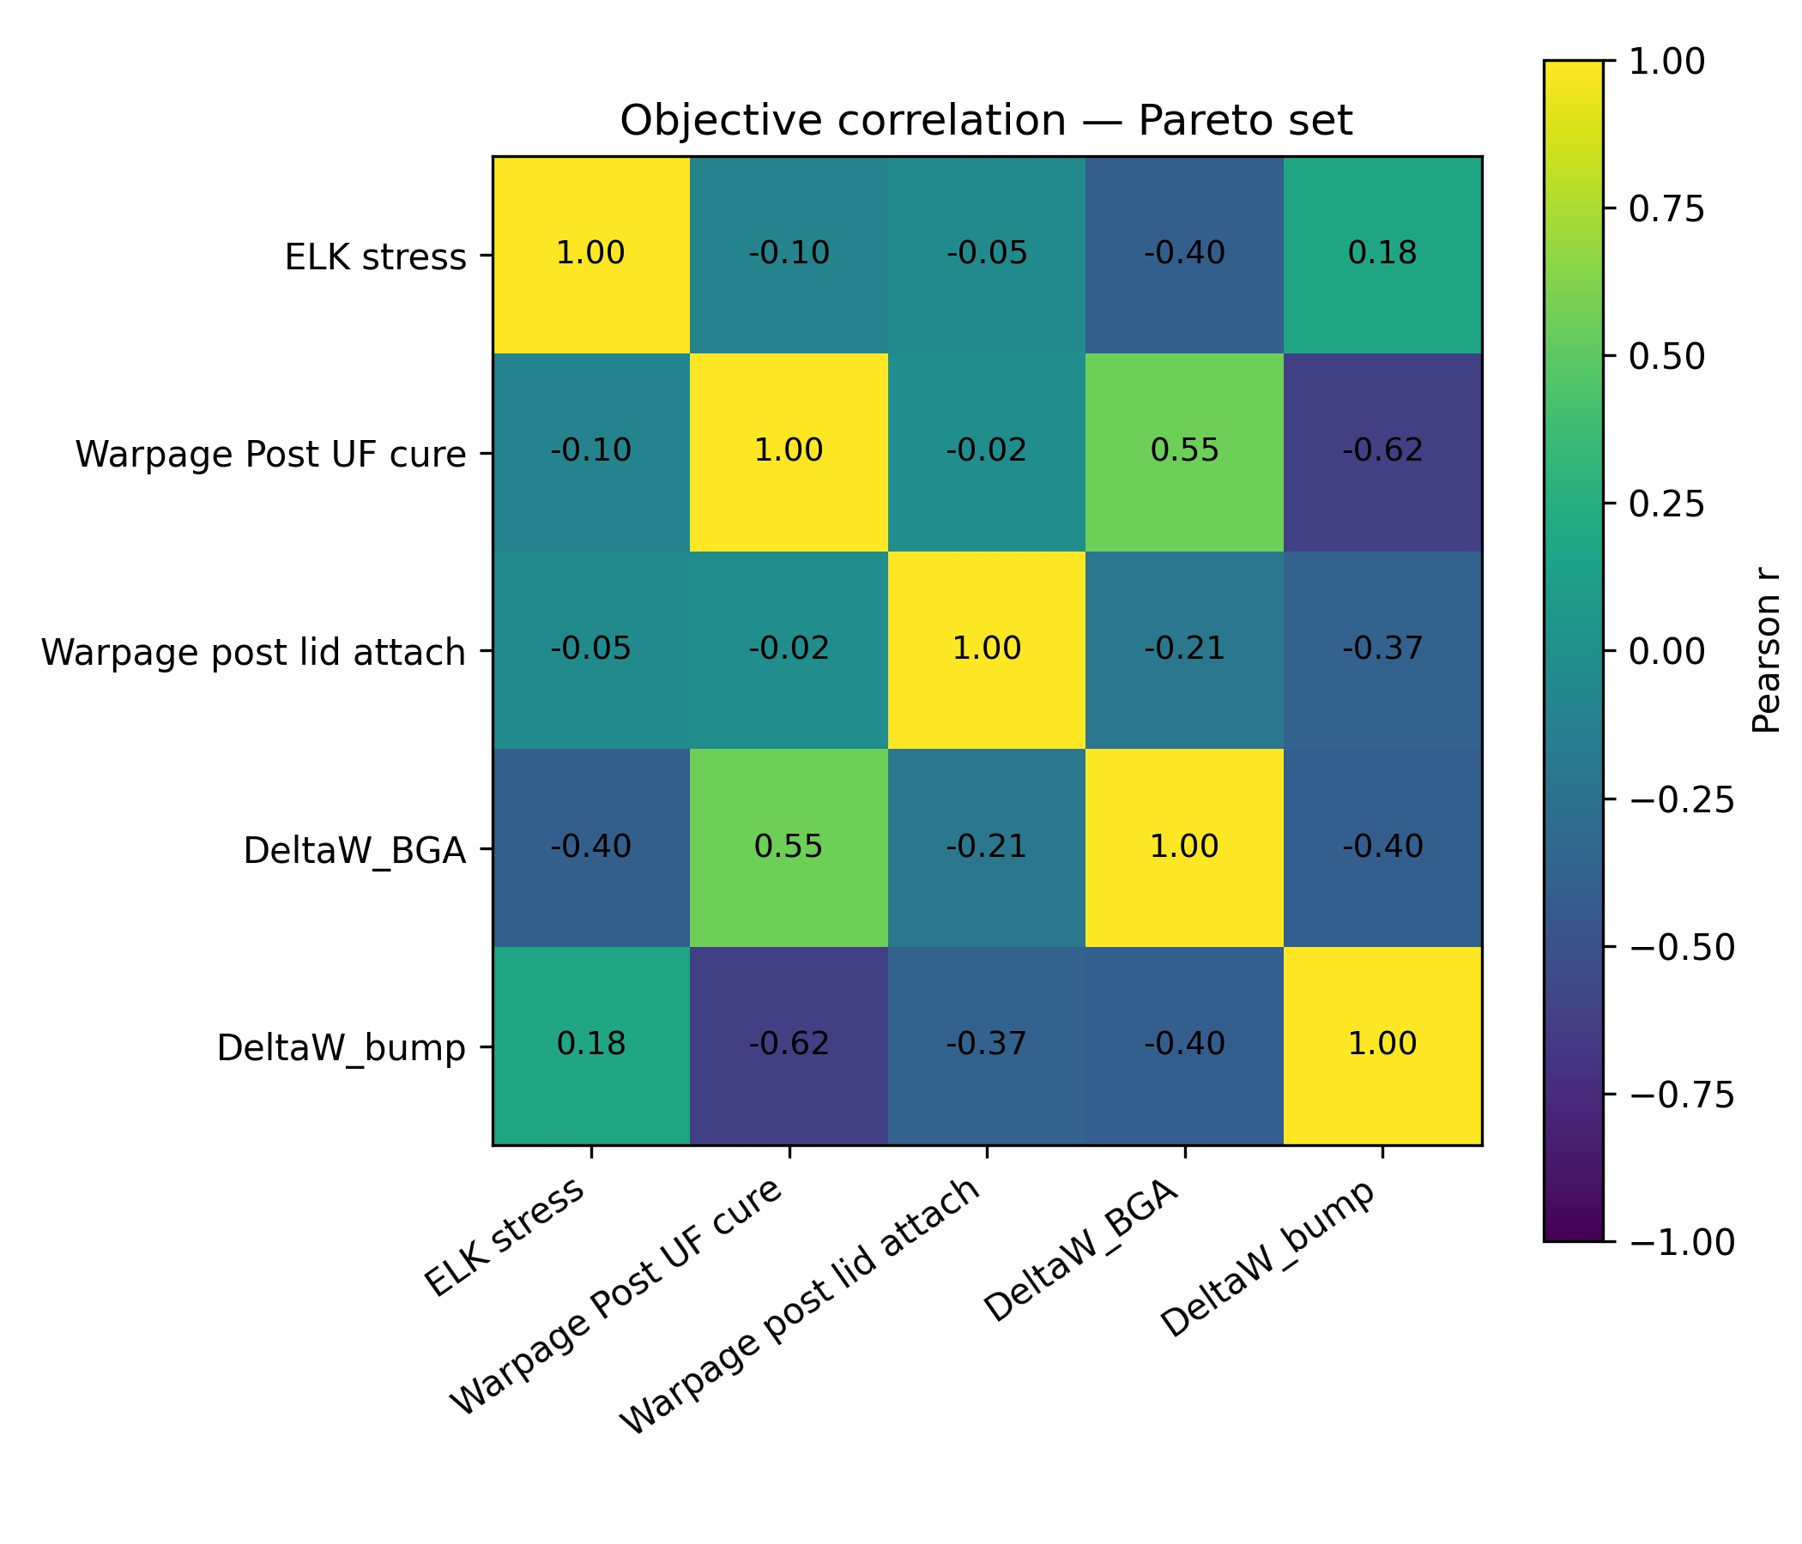
Figure 9: Correlation heatmap of the objectives recomputed over the 150 Pareto-optimal solutions.
essentially uncorrelated (r = −0.08) across the design space, underscoring how strongly the lidattach step reshapes the warpage behavior as design parameters vary.
These near-zero correlations carry a clear engineering message: the assembly-stage objectives and the reliability objectives are only weakly coupled across this design space. No single response can serve as a reliable proxy for the others—minimizing ELK stress, for example, provides essentially no information about post-lid-attach warpage and is, if anything, very weakly anti-correlated with BGA-level fatigue damage. Two consequences follow. First, the decoupling directly motivates the genuine multi-objective formulation of Section 2.5: a scalarized single-objective opti-
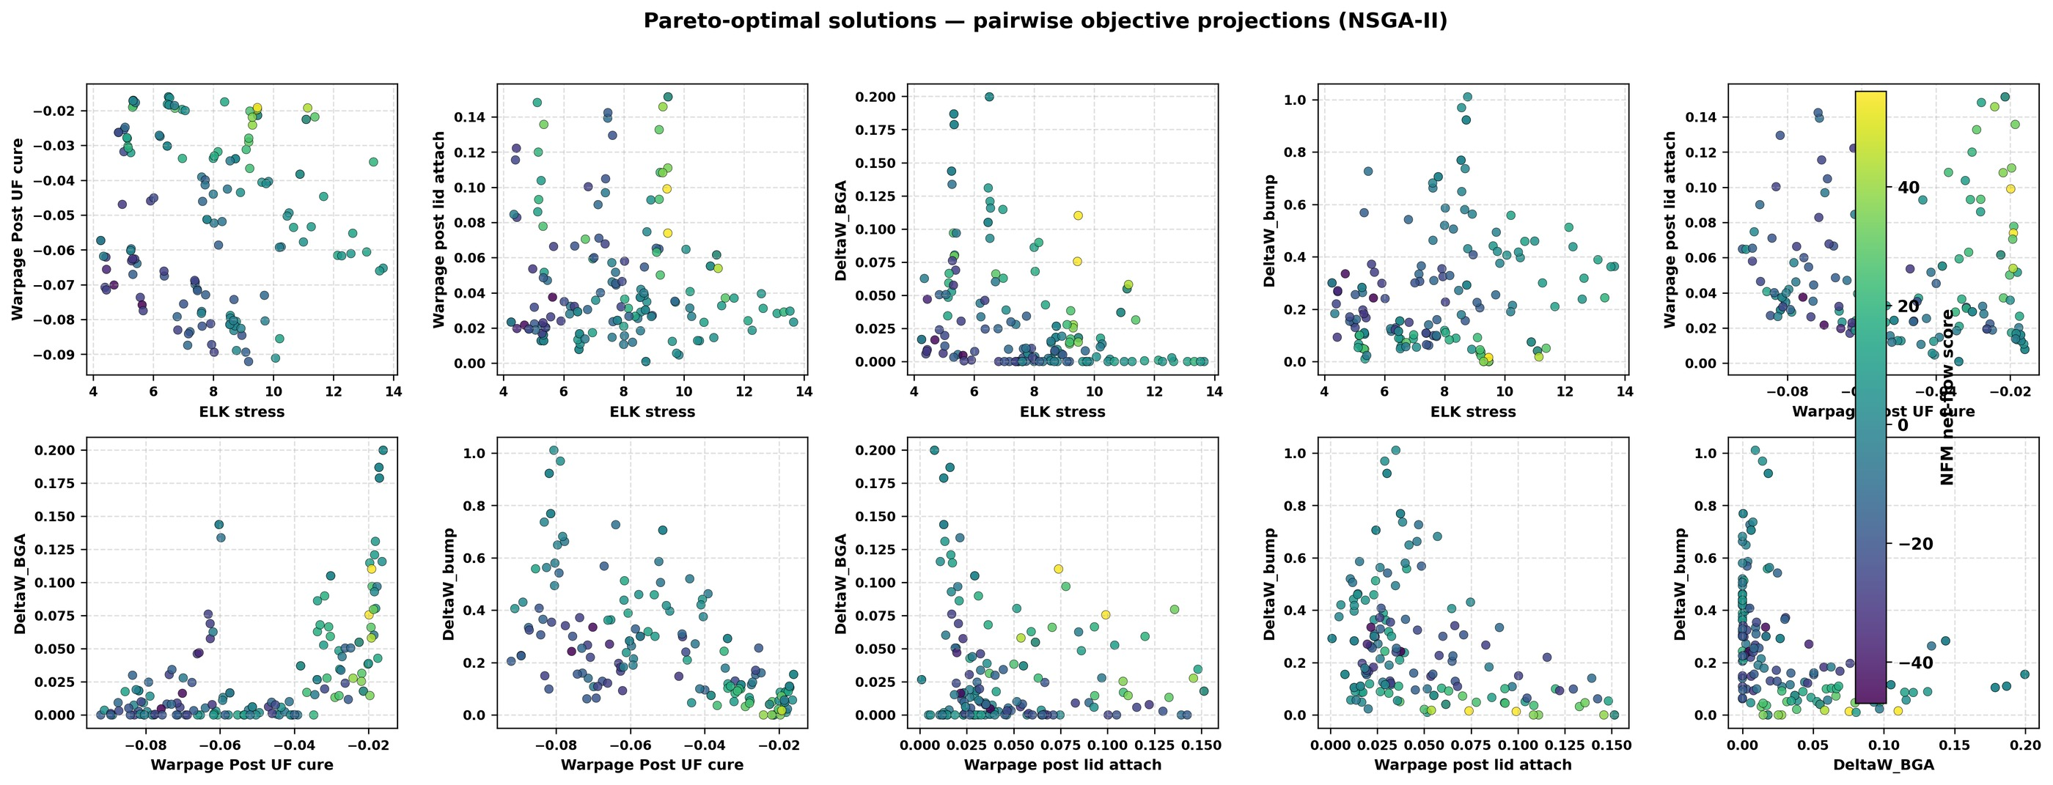
Figure 10: Pareto-optimal solutions obtained from NSGA-II for the FCBGA-with-lid co-design problem, shown as pairwise objective projections.
optimization of one response with the others merely monitored, would risk silently degrading the unmonitored responses. Second, it implies that the Pareto front is intrinsically highdimensional and well-populated: with weakly correlated objectives, few designs are dominated, and a rich trade-off surface exists to be mapped.

NSGA-II Pareto Front Analysis
NSGA-II converged to a set of 150 Pareto-optimal designs, i.e., a full population of mutually non-dominated solutions at termination. Figure 10 shows the pairwise scatter projections of the Pareto front over all ten objective pairs, and Fig. 13 presents RadViz projections of the front—one panel per objective, colored by that objective’s value—with the NFM champion marked.
The pairwise projections confirm genuine trade-offs: no single design simultaneously attains the minimum of all five objectives. Designs at the low-ELK-stress extreme of the front tend to sit away from the low-∆W_{BGA} extreme, consistent with the weak negative correlation (r = −0.16) reported in Section 3.3, and the two warpage objectives spread nearly independently of the reliability metrics, producing broad, weakly structured point clouds rather than sharp trade-off curves. This morphology—diffuse clouds rather than crisp fronts in two-dimensional projection—is characteristic of five-objective problems with weak pairwise coupling: the true front is a four-dimensional manifold, and any two-dimensional projection collapses the remaining trade-off directions.
The Pareto set is therefore valuable in two distinct ways. First, it maps the achievable trade-off surface for FCBGA-with-lid design under the trained surrogates, letting an engineer read off, for instance, how much predicted ∆W_{BGA} must be conceded to reach a given predicted ELK stress level. Second—and precisely because 150 non-dominated candidates remain after optimization— the front by itself does not identify a recommended design; domination alone cannot discriminate among them. This motivates the outranking-based ranking step whose results follow.

NFM Ranking and Champion Design
Figure 11 overlays the NFM scores on the pairwise objective projections of the Pareto set, with the champion highlighted, and Fig. 12 shows the distribution of net flow scores over the 150 Pareto solutions. The histogram exhibits a broad spread of scores with a thin high-scoring tail, indicating that the outranking procedure—with its indifference, preference, and veto thresholds— meaningfully discriminated among the non-dominated candidates rather than assigning near-uniform scores. The pairwise NFM scatter additionally shows that high-scoring designs concentrate in the balanced central regions of the objective projections rather than at single-objective extremes, which is the expected behavior of an equal-weight outranking rule with a veto mechanism.
The RadViz visualization in Fig. 13 provides a complementary view. In RadViz, each objective defines an anchor on the unit circle and each design is placed at the equilibrium of spring forces proportional to its normalized objective values; designs pulled toward a particular anchor are relatively poor in that objective, while interior points represent balanced compromises. The panels show the front populating both anchor-leaning arcs—specialist designs that sacrifice one objective—and a balanced interior cluster. The champion lies in the interior, visually confirming that the NFM selected a compromise design rather than an extreme solution optimized for only
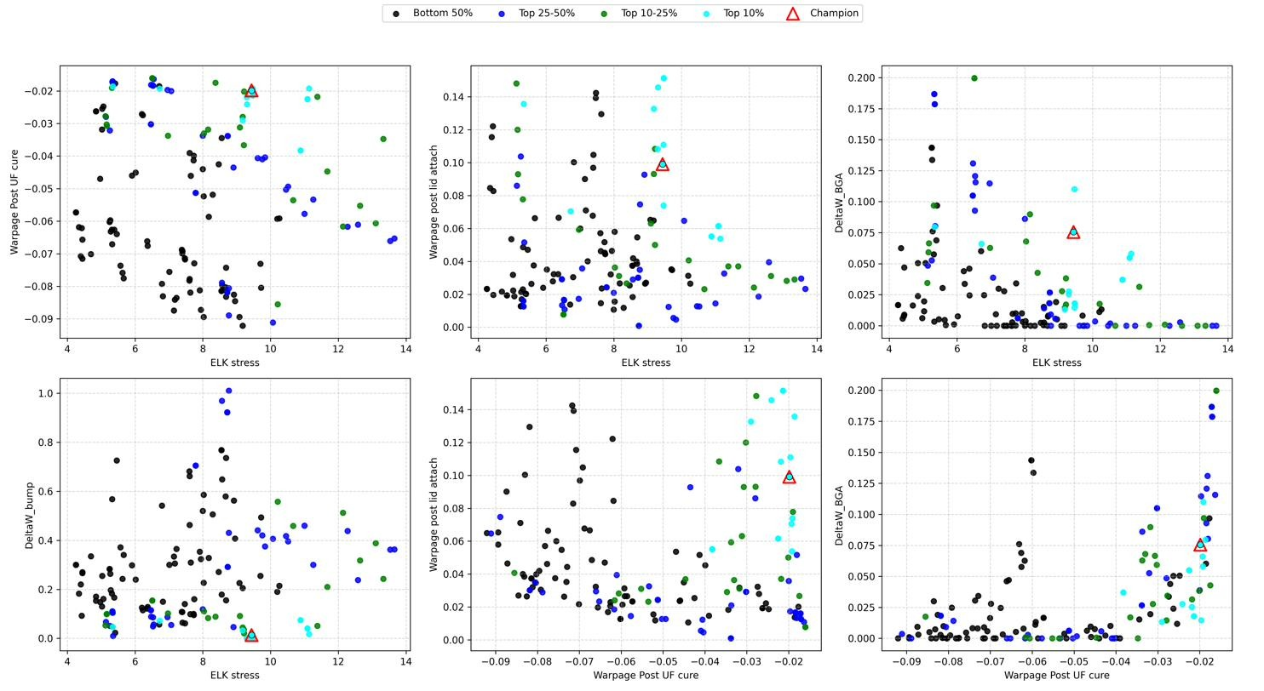
Figure 11: NFM-ranked Pareto solutions showing the trade-off structure and the selected champion design.

Table 9: NFM-selected champion design.
Parameter | Value
Bulk silicon thickness | 0.25 mm
Bump solder height | 0.06 mm
Substrate core thickness | 1.2 mm
Lid foot width | 6 mm
Lid thickness | 1.5 mm
Cu-pillar solder material | SAC405
BGA solder material | SAC105
NetFlow score | 56.10
one response.
The top-ranked (champion) design achieved a NetFlow score of 56.10. Its design parameters are listed in Table 9 and its ML-predicted objective values in Table 10.
Two caveats frame these results. First, the champion was selected as the best-compromise design under the equal-weight NFM rule with the stated Q/P/V thresholds; it does not minimize any individual objective, and other Pareto members achieve lower values of individual objectives at the cost of others. A different weighting—for example, up-weighting the reliability metrics
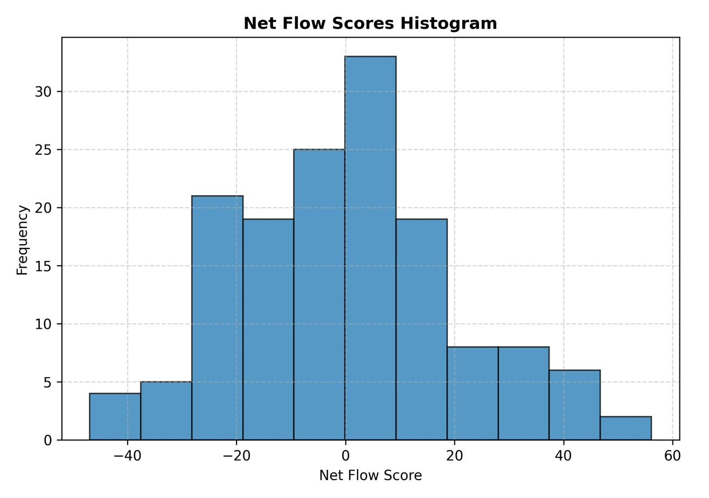
Figure 12: Distribution of Net Flow Method scores over the 150 Pareto-optimal solutions.
Table 10: ML-predicted objective values of the champion design.
Objective | ML-predicted value
ELK stress | 9.44
Warpage after UF cure | −0.020
Warpage after lid attach | 0.099
∆W_{BGA} | 0.075
∆W_{bump} | 0.013

for an automotive application—or different threshold fractions would in general select a different champion, so the ranking should be understood as one defensible resolution of the trade-off, not a unique optimum. Second, the objective values in Table 10 are surrogate predictions whose perobjective trustworthiness varies enormously (Section 3.1): the ELK stress prediction is backed by a 0.9851 test R², whereas the post-lid-attach warpage prediction is backed by a surrogate whose cross-validated skill is indistinguishable from the mean predictor. The predicted values for the
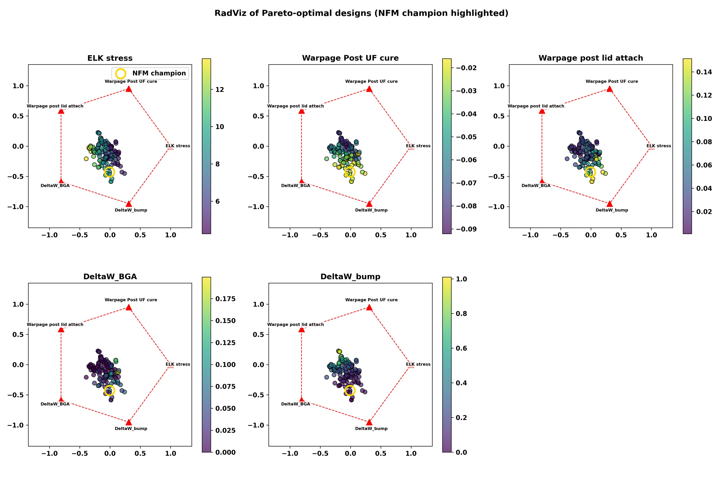
Figure 13: RadViz visualization of Pareto-optimal designs with the objective names on each plot and the NFM-selected champion design highlighted.
Table 11: Champion ML predictions versus the nearest existing FEA/DOE design (ID 277).
Target | ML pred. | FEA (ID 277) | Rel. error
ELK stress | 9.44 | 11.75 | 19.7%
Warpage after UF cure | −0.020 | −0.045 | 55.5%
Warpage after lid attach | 0.099 | 0.029 | 240%
∆W_{BGA} | 0.075 | 0.0015 | 5035%
∆W_{bump} | 0.013 | 0.413 | 96.8%

weak objectives should be regarded as placeholders pending direct FEA evaluation.

Validation Proxy
Table 11 compares the champion’s ML-predicted objectives against the FEA ground truth of the nearest simulated design under the mixed distance metric of Section 2.7, which was Design ID 277. The nearest neighbor shares the champion’s substrate-core and underfill material levels, lid geometry, and both solder alloys, but differs in three numerical variables—bulk silicon thickness (0.50 versus 0.25 mm), bump solder height (0.02 versus 0.06 mm), and substrate core thickness (0.8 versus 1.2 mm)—so a substantial part of any discrepancy reflects genuine design-space distance rather than surrogate error.
The comparison must therefore be read as a plausibility check, and the observed discrepancies are consistent with both the surrogate quality hierarchy of Section 3.1 and the design distance to the neighbor.
For ELK stress, the best-modeled response, the champion prediction of 9.44 differs from the neighbor’s simulated 11.75 by 19.7%. This is not primarily surrogate error: the neighbor’s bump solder height (0.02 mm versus the champion’s 0.06 mm) and bulk silicon thickness (0.50 mm versus 0.25 mm) differ substantially, and both are leading drivers of ELK stress, so a genuinely lower stress at the taller-bump, thinner-die champion is physically expected. For warpage after underfill cure, the prediction of −0.020 against the neighbor’s −0.045 (absolute difference 0.025) is likewise consistent with the champion’s thicker 1.2 mm core—the dominant driver of this response—stiffening the substrate relative to the neighbor’s 0.8 mm core; the prediction reproduces the correct sign and order of magnitude.
The remaining three targets showed discrepancies too large to be attributed to design distance alone. Post-lid-attach warpage disagreed by 240% (0.099 predicted versus 0.029 simulated)—the surrogate predicted more than three times the warpage of the nearest FEA design—which is unsurprising for a model whose cross-validated R² is negative. ∆W_{BGA} disagreed by more than an order of magnitude in the conservative direction (0.075 predicted versus 0.0015 simulated), an overprediction consistent with a weak surrogate hedging toward the dataset mean while the neighbor happens to lie at the low-damage extreme of the response. ∆W_{bump} disagreed by 96.8% in the opposite, non-conservative direction (0.013 predicted versus 0.413 simulated): the surrogate-optimized champion claims far lower bump damage than the nearest real simulation exhibits. Bump solder height, which differs by a factor of three between champion and neighbor, is the dominant ∆W_{bump} driver, so part of this gap is physical—but the direction of the error matters, because optimistic bias at the optimum is exactly the failure mode that surrogate-based optimization is known to produce when the optimizer exploits regions where a model of limited fidelity is erroneously optimistic.
Two interpretive points are essential. First, these discrepancies confound surrogate error with genuine design-space distance: Design ID 277 is the nearest neighbor, not the champion itself, and the three differing numerical variables include dominant drivers of several objectives; none of the reported percentages can be decomposed into surrogate error and physical difference without a direct re-simulation, which was not performed in this study. Second, the direction of the ∆W_{bump} error is non-conservative: the champion claims lower bump damage than the nearest real simulation exhibits, which would be misleading if taken at face value for reliability assessment. Accordingly, this proxy comparison must not be presented as an FEA confirmation of the champion design. It indicates that the well-modeled assembly objectives behave in a physically consistent manner across the champion and its neighbor, and it flags the reliability objectives and post-lid-attach warpage as requiring direct FEA evaluation before any engineering conclusion is drawn from their predicted values.

Discussion

Surrogate Fidelity and Target-Dependent Learnability
The most salient finding is the pronounced target dependence of learnability from an identical 300-point DOE. On the same data, CatBoost test R² ranged from 0.9851 (ELK stress) to 0.1373 (post-lid-attach warpage), where no CatBoost depth reached a positive cross-validated R² and the best of 24 tuned ANN configurations reached only 0.026. With feature set, sample size, and protocol held constant, this spread reflects the responses themselves—how much of each one’s variance is a learnable function of the sampled variables.
The well-predicted responses fit this view. ELK stress and underfill-cure warpage are governed by global thermo-elastic mechanics—the stiffnesses and CTEs of die, underfill, and substrate combining into smooth, largely monotonic curvature and stress fields—which shallow gradient-boosted trees capture readily; CatBoost at depth 3–4 sufficed, and deeper trees only overfit (ELK-stress CV R² fell from 0.9795 at depth 4 to 0.9603 at depth 6). Once properly scaled, the improved ANN also captured these responses well, confirming their intrinsic learnability.
The poorly predicted responses fail for compounding reasons. First, lid attachment imposes a statically indeterminate, strongly nonlinear constraint—stiff lid, compliant adhesive foot, and TIM on an already-warped assembly—so the post-attach shape depends on interacting combinations of lid geometry, substrate stiffness, and prior warpage, not additive main effects [4], [5], [6]; learning such high-order interactions reliably needs far more than 300 points. Second, ∆W_{BGA} and ∆W_{bump} are localized damage metrics with a higher noise floor than package-level responses [15], [17]. Third, nine mixed variables at 300 points leave interaction cells sparsely populated, making interaction-dominated responses statistically unidentifiable. Fourth, physics-relevant composites (CTE-mismatch, stiffness ratios, adhesive compliance) were not supplied as features and had to be reconstructed from raw variables.
The cross-validation sweeps are decisive: no CatBoost depth and no tuned ANN configuration materially improved the weak targets. When added capacity and regularization cannot help, the bottleneck is information—features and samples—not modeling technique, which shapes the remediation plan of Section 4.5. CatBoost’s consistent advantage over the improved ANN reflects a general property of small tabular DOE data. Boosted trees are depth-controlled, need no feature scaling, handle one-hot categoricals natively, and stay stable on 240 rows, whereas a perceptron must estimate many scale-sensitive weights from the same rows—why the baseline ANN failed outright and the improved ANN only approached, never exceeded, CatBoost. Regularized boosted trees are therefore the more reliable default for discrete-level, mixed-type DOE data at this scale.
Finally, the single-split test R² of 0.1373 for post-lid-attach warpage overstates skill relative to its cross-validated performance, which was negative at every depth; with only 60 test points, single-split metrics for weak models carry large variance. Cross-validated diagnostics are therefore the authoritative measure for weak targets, and both are reported to make the gap visible.

Multi-Objective Trade-Offs and Objective Decoupling
All pairwise objective correlations were below |r| = 0.17 across the 300 designs, the largest being ∆W_{BGA}–∆W_{bump} (r = +0.15) and ELK stress–∆W_{BGA} (r = −0.16). Three aspects deserve emphasis.
First, the near-decoupling between assembly stress/warpage and solder-fatigue indicators means assembly and reliability optimization cannot be treated as one problem for lidded FCBGA packages: decisions optimal for one set carry essentially no guarantee for the other. A change that lowers ELK stress—say a more compliant bump alloy—brings no automatic reliability gain and may weakly worsen ∆W_{BGA} (r = −0.16).
Second, the two solder-damage metrics track each other only weakly (r = +0.15) because bump and BGA joints sit at different points in the load path: bump damage follows the local die–substrate mismatch across the underfilled standoff, BGA damage the package–board mismatch filtered through substrate bending. Design variables act on them with different, sometimes opposing, leverage—bump solder height being the clearest case—so reliability sign-off must evaluate both levels; neither proxies the other.
Third, the weak coupling justifies the optimization architecture: with nearly independent objectives, a weighted sum would explore only a thin, weight-sensitive slice of the trade-off surface, so a Pareto method (NSGA-II) is needed to expose the full compromise structure and a separate transparent MCDM step (NFM) to inject preferences. The Pareto front filling its full 150-member population is itself a consequence of this weak coupling, where domination is rare.

Champion Design Interpretation
The champion (Table 9) is physically interpretable via Section 3.2. SAC405 bump solder places the design in the stiff, high-silver regime: since bump alloy dominated ELK stress (soft SAC105 most important), avoiding the compliant regime reflects the balance NSGA-II struck between stress transfer into the ELK stack and bump inelastic work, the stiffer alloy also giving lower bump plasticity—consistent with the low predicted ∆W_{bump} of 0.013 (medium-fidelity, still warranting FEA). SAC105 BGA solder puts the second-level joints in the soft regime and carried high ∆W_{BGA} importance, so it reflects the optimizer exploiting a lever from a surrogate weak for that response; low-silver alloys also remain a common cost-effective choice [16].
The 0.06mm bump height serves two fronts (leading features for both ELK stress and ∆W_{bump}): the tall, compliant standoff accommodates first-level shear, relieving the ELK stack and the bump solder. The 0.25mm die is the thinnest, most compliant level, lowering die bending stiffness and ELK curvature, and the 1.2mm core maximizes the substrate bending stiffness dominating underfill-cure warpage [7]. The lid (1.5mm, 6.0mm foot) takes intermediate stiffening levels per the equal-weight rule; but with the post-lid-attach warpage surrogate at near-zero CV skill, confidence here is low and the lid geometry most needs direct FEA.
Overall, the champion is a physically sensible starting point from an equal-weight compromise rule—a coherent DOE-grid configuration whose strong-surrogate objectives are trustworthy and whose weak-surrogate objectives are hypotheses—not a final qualified design.

Comparison with Literature
This study parallels recent thermo-mechanical co-design work on 2.5D flip-chip packages with silicon/glass interposers [22]: both share an FEA-generated DOE, per-target ML surrogates with quality diagnostics, NSGA-II on the surrogates, RadViz visualization, and Net Flow Method ranking, and both treat the ML layer as a screening instrument feeding high-fidelity analysis rather than replacing FEA.
The differences are substantive. This work addresses a single-die lidded FCBGA, not a 2.5D interposer assembly, so there is no interposer hierarchy or thermal objective; the responses instead extend to lid-attach warpage and two solder-reliability levels. The design space spans lid geometry, alloy selection at both levels, and paired underfill and core properties [3], [4]. The lid adds nonlinear interactions—adhesive-foot constraint, TIM coupling, stiffening of a pre-warped assembly—with no interposer analog, which surfaced as the weakest surrogate target [5], [6]. Most consequentially, [22] re-solved its champion directly, whereas this work offers only a nearest-neighbor proxy, a materially weaker validation treated as such throughout.
The qualitative findings align with the broader flip-chip/FCBGA literature: substrate core stiffness and CTE as warpage levers [7], [9]; process history and material behavior complicating warpage prediction [8], [10], [11]; alloy composition and joint geometry driving die stress and solder fatigue [3], [15]; underfill selection affecting reliability [14]; and ML-assisted optimization accelerating DOE-based flows [19], [20], [21]. This work adds a quantitative five-objective trade-off map—and an unusually explicit account of where such surrogates fail—for the lidded-FCBGA space.

Limitations and Future Work
The limitations bound what the results support. (i) Only 300 points over a mixed discrete/categorical space under-sample interaction effects. (ii) Two objectives rest on weak surrogates (test R² 0.1373 for post-lid-attach warpage, 0.1998 for ∆W_{BGA}) and a third (∆W_{bump}, 0.4761) is borderline-medium, so their contributions to the Pareto geometry and NFM ranking are of limited fidelity, and the optimizer may exploit regions where these models are optimistic. (iii) CatBoost used one fixed depth while only the ANN was tuned per target. (iv) No ANSYS re-simulation of the champion or any Pareto member was performed—no objective is confirmed by a dedicated re-solve, and no steady-state thermal or follow-up simulation was included. (v) Validation used only the nearest FEA design (ID 277), confounding surrogate error with design-space distance, as the neighbor differs in three dominant-driver variables. (vi) The CV sweeps show the weak targets need more samples and better physics-based features, not more capacity.
Future work should proceed by leverage. First, a dedicated ANSYS re-simulation of the champion and several high-ranked Pareto members would give true, unconfounded validation errors for all five objectives. Second, adaptive DOE enrichment near the Pareto front—and where weak surrogates disagree most with their CV folds—is far more sample-efficient than uniform densification. Third, physics-informed features (CTE-mismatch and stiffness-ratio terms, effective bending stiffness, analytical strain-energy indicators) would let models learn corrections to physics rather than physics from scratch. Fourth, uncertainty-aware surrogates for local damage (log-scaled work densities, Gaussian processes, multi-fidelity FEA), with that uncertainty propagated through the optimization, would keep weak objectives from being trusted at face value. Fifth, sensitivity analysis over NSGA-II and NFM settings should test the robustness of champion selection, and process variables—lid-attach behavior, cure history, residual stress—should be added to target the unlearnable post-lid-attach warpage [8], [13]. Finally, thermal validation (steady-state and thermal-cycling confirmation of the champion) was outside the current dataset and is left as future work, since this study is confined to thermo-mechanical assembly and solder-joint reliability responses.

Practical Engineering Recommendations
The results support graded recommendations. The ELK-stress and underfill-cure warpage surrogates (test R² 0.9851 and 0.9796, CV R² near 0.98) suffice for early screening, sensitivity ranking, and trade-off exploration, triaging candidates before FEA. The ∆W_{bump} surrogate (0.4761) supports trend-level reliability screening but not sign-off, given its non-conservative proxy discrepancy. Post-lid-attach warpage and ∆W_{BGA} should not inform decisions without direct FEA (proxy errors of 240% and over an order of magnitude). Bump solder height and alloy selection should be first-order variables, dominating the ELK-stress, ∆W_{bump}, and ∆W_{BGA} rankings, with underfill and core properties tuned jointly. The champion (Table 9) is a starting design for FEA confirmation, not a production-ready solution. In summary, the surrogate predictions should be trusted in strict proportion to their demonstrated fidelity. Table 12 condenses this into an engineering-confidence summary and identifies direct ANSYS re-simulation of the champion design as the required next step before final engineering conclusions.
Table 12. Engineering-confidence summary of the surrogate predictions and the required next step before final engineering use.
Confidence tier | Response(s) | Recommended use
Trusted (high confidence) | ELK stress; warpage after UF cure (test R² = 0.9851 and 0.9796) | Suitable for early-stage design screening, sensitivity ranking, and trade-off exploration
Partially useful (borderline-medium) | ∆W_{bump} (test R² = 0.4761) | Trend-level reliability screening only; not for sign-off, given the non-conservative proxy error
Low confidence | Warpage after lid attach; ∆W_{BGA} (test R² = 0.1373 and 0.1998) | Not to be used for engineering decisions without direct FEA validation
Required next step | Champion design (all five objectives) | Direct ANSYS re-simulation of the champion design before any final engineering conclusion

In summary, the FEA–ML–NSGA-II–NFM workflow proved useful for early-stage exploration: it produced trustworthy surrogates for the dominant assembly responses, honestly identified the responses the current variables cannot reliably predict, exposed the weak coupling between assembly and reliability objectives, mapped the five-objective trade-off surface with 150 Pareto designs, and delivered an interpretable balanced-compromise champion. Final qualification, however, still requires direct high-fidelity FEA validation of the selected design and ultimately experimental reliability testing.

Conclusion
This work presented a machine-learning-assisted thermo-mechanical and reliability co-design workflow for an FCBGA package with lid. Two FEA-generated datasets were used: an assembly dataset for ELK stress and warpage responses, and a solder-joint reliability dataset for ∆W_{BGA} and ∆W_{bump}. Separate artificial neural network (ANN) and CatBoost surrogate models were trained per response for the assembly and SJR datasets, with CatBoost selected as the final surrogate for all five objectives, while the paired Design ID data were used for multi-objective co-design.
The best surrogate performance was obtained for ELK stress and warpage after underfill cure, with CatBoost test R² values of 0.9851 and 0.9796, respectively. The model for ∆W_{bump} showed borderline-medium accuracy with a test R² of 0.4761. In contrast, warpage after lid attachment and ∆W_{BGA} remained weakly predicted, with test R² values of 0.1373 and 0.1998, respectively, and negative or near-zero cross-validated scores. The ANN proved highly sensitive to preprocessing: without input standardization, target scaling, early stopping, and cross-validated hyperparameter tuning it failed outright on the warpage-related objectives, and even after improvement it did not surpass CatBoost on any target. These results indicate that some responses are well represented by the available design variables, while others require additional process or local geometry parameters before they can be modeled reliably.
The trained surrogate models were then used in an NSGA-II multi-objective optimization workflow to identify Pareto-optimal package designs across five minimized objectives. NFM ranking was applied to select a balanced champion design from the Pareto set, and the champion’s predictions were compared against the nearest existing DOE/FEA simulation case as a proxy validation. The selected design provides a useful starting point for package co-design, but it should be validated with direct FEA re-simulation before final engineering use, especially because some objectives were predicted with limited accuracy.
Overall, the results show that ML surrogate modeling can accelerate FCBGA-with-lid design exploration and provide interpretable guidance on important design parameters. Future work should focus on ANSYS re-simulation of the champion design, additional DOE points for weak response regions, and expanded process variables such as lid attach material behavior, cure history, and residual stress.

Data Availability
The project files, scripts, generated figures, and processed datasets are available at: https://github.com/baharprh/FCBGA-with-Lid-ML.

References
[1] N. Kao, J. Li, J. Li, and Y.-P. Wang, “Large-Size Multi-Layered Fan-Out RDL Multi-Chip Module Packaging,” Chip Scale Review, vol. 26, no. 2, pp. 28–33, 2022.
[2] H. Dang et al., “A Detailed Thermal Resistance Network Analysis of FCBGA Package,” Journal of Thermal Science, vol. 33, no. 1, pp. 18–28, 2024, doi: 10.1007/s11630-023-1903-y.
[3] B.-H. Chen, A. Wang, W.-H. Lai, C.-P. Hung, and C.-L. Kao, “High-Performance Flip-Chip BGA Packages Reliability Prediction in Automotive Applications,” in 2024 IEEE CPMT Symposium Japan (ICSJ), IEEE, 2024, pp. 224–227. doi: 10.1109/ICSJ62869.2024.10804730.
[4] M. B. Jeronimo, J. Schindele, H. Straub, P. J. Gromala, B. Wunderle, and A. Zimmermann, “On the Influence of Lid Materials for Flip-Chip Ball Grid Array Package Applications,” Microelectronics Reliability, vol. 140, p. 114869, 2023, doi: 10.1016/j.microrel.2022.114869.
[5] X. Peng, C. Zhong, and C. Li, “The Influence of Lid to the Stress of Underfill in Flip-Chip Package,” in 2022 23rd International Conference on Electronic Packaging Technology (ICEPT), IEEE, 2022. doi: 10.1109/ICEPT56209.2022.9873457.
[6] H. Jung et al., “Module Stress Reduction for 2.5D TSV-based Heterogeneous Package,” in 2025 IMAPS Symposium, San Diego, CA, USA: IMAPS, 2025.
[7] S. Ramdas, T. Chauhan, D. R. Shirley, and R. Coccioli, “Impact of Core Material Coefficient of Thermal Expansion (CTE) on Warpage Assessment of Larger FCBGA Package with Stiffener Ring,” in Proc. ASME 2025 Int. Tech. Conf. and Exhibition on Packaging and Integration of Electronic and Photonic Microsystems (InterPACK2025), Anaheim, CA, USA: ASME, 2025.
[8] H.-C. Cheng, L.-C. Tai, and Y.-C. Liu, “Theoretical and Experimental Investigation of Warpage Evolution of Flip Chip Package on Packaging during Fabrication,” Materials, vol. 14, no. 17, p. 4816, 2021, doi: 10.3390/ma14174816.
[9] Y.-H. Chen, L.-C. Tai, Y.-C. Liu, and H.-C. Cheng, “A Study of Factors Affecting Process-Induced Warpage Behavior of Flip Chip Package on Package,” in 2021 International Conference on Electronics Packaging (ICEP), IEEE, 2021, pp. 105–106. doi: 10.23919/ICEP51988.2021.9451980.
[10] A. Salahouelhadj, M. Gonzalez, K. Vanstreels, G. der Plas, G. Beyer, and E. Beyne, “Analysis of Warpage of a Flip-Chip BGA Package under Thermal Loading: Finite Element Modelling and Experimental Validation,” Microelectron. Eng., vol. 271–272, p. 111947, 2023, doi: 10.1016/j.mee.2023.111947.
[11] J.-H. Baek, D.-W. Park, G.-H. Oh, D.-O. Kawk, S. S. Park, and H.-S. Kim, “Effect of Cure Shrinkage of Epoxy Molding Compound on Warpage Behavior of Semiconductor Package,” Mater. Sci. Semicond. Process., vol. 148, p. 106758, 2022, doi: 10.1016/j.mssp.2022.106758.
[12] H.-J. Um, Y.-M. Ju, D.-W. Lee, J. Ahn, and H.-S. Kim, “Reduced Warpage in Semiconductor Packages: Optimizing Post-Cure Temperature Profile Considering Cure Shrinkage and Viscoelasticity of Epoxy Molding Compound,” Mater. Des., vol. 245, p. 113265, 2024, doi: 10.1016/j.matdes.2024.113265.
[13] P.-Y. Lin, “Warpage Modeling of Ultra-Thin Packages Based on Chemical Shrinkage and Cure-Dependent Viscoelasticity of Molded Underfill,” IEEE Transactions on Device and Materials Reliability, vol. 20, no. 1, pp. 67–76, 2020, doi: 10.1109/TDMR.2020.2966300.
[14] Z. Plachý, A. Pražanová, K. Dušek, and A. Géczy, “Underfill: A Review of Reliability Improvement Methods in Electronics Production,” Electronics (Basel)., vol. 14, 2025.
[15] J. Gao and J. B. Kwak, “Reliability and Thermal Fatigue Life Prediction of Solder Joints for Advanced Automotive Microelectronics,” Journal of Mechanical Science and Technology, vol. 35, no. 8, pp. 3633–3641, 2021, doi: 10.1007/s12206-021-0734-6.
[16] R. K. Apalowo, M. A. Abas, F. Che Ani, M. A. F. Muhamed Mukhtar, and M. R. Ramli, “Thermal Fatigue Life Prediction and Intermetallic Compound Behaviour of SAC305 BGA Solder Joints Subject to Accelerated Thermal Cycling Test,” Soldering & Surface Mount Technology, 2024.
[17] H. Yang and Z. Xu, “Thermal Fatigue Life Prediction of Ag-2.5Sn Solder Joint in Flip Chip,” J. Adhes. Sci. Technol., vol. 38, no. 18, pp. 3525–3540, 2024, doi: 10.1080/01694243.2024.2345955.
[18] B. George, G. M. Reuther, I. Rau, M. Niessner, and H. F. Bin Muhamad Zul, “Subcritical Crack Propagation in Solder Resist Materials During Fatigue Bulge Testing in Experiment and Simulation,” in 2026 27th Int. Conf. on Thermal, Mechanical and Multi-Physics Simulation and Experiments in Microelectronics and Microsystems (EuroSimE), IEEE, 2026. doi: 10.1109/EuroSimE69483.2026.11511914.
[19] H. Wu and W. Chu, “Machine Learning Assisted Structural Design Optimization for Flip Chip Packages,” in 2021 6th International Conference on Integrated Circuits and Microsystems (ICICM), IEEE, 2021, pp. 132–136. doi: 10.1109/ICICM54364.2021.9660367.
[20] Q. Zhang, C. Zhong, and S. Rong, “Study on Warpage of Flip Chip Structure Based on Finite Element Analysis and Machine Learning Algorithm,” in 2024 25th International Conference on Electronic Packaging Technology (ICEPT), IEEE, 2024, pp. 1–6. doi: 10.1109/ICEPT63120.2024.10668739.
[21] S. K. Panigrahy, F. X. Che, Y. C. Ong, H. W. Ng, and G. Kumar, “Deep Learning Study on Memory IC Package Warpage Using Deep Neural Network and Finite Element Simulation,” Electronics (Basel)., vol. 14, 2025.
[22] M. Rafiee, F. Agin, K. Kumar, and E. Murali, “Thermo-Mechanical Co-Design of 2.5D Flip-Chip Packages with Silicon and Glass Interposers via Finite Element Analysis and Machine Learning,” Microelectronics Reliability, vol. 176, p. 115983, 2026, doi: 10.1016/j.microrel.2025.115983.

